Riga Technical University

FACULTY OF COMPUTER SCIENCE AND INFORMATION TECHNOLOGY

Fundamentals of Computer Graphics and Image Processing

Practical Work 1
TASK 2. CIRCLE LINE ALGORITHEM
AND ADDITIONAL TASK

FCSIT
International Student
ZAID AHMAD SIDDIQUI
Stud. ID Nr.191ADB044

1.Task of Work
- During class you will be given the first half of the Circle line algorithm that can draw 1/8 of a circle, complete this algorithm so that it could draw a full circle (using symmetry). The circle should always be drawn in the center of the program window, the radius is defined through a text field.
- Upload the protocol of the task to Ortus (in *.pdf, *.doc or *.docx formats)

Programming Code
Graphics g = jPanel1.getGraphics();
g.setColor(Color.WHITE);
//g.drawLine(0,0,jPanel1.getWidth(),jPanel1.getHeight());
// g.drawLine(0,jPanel1.getHeight(),jPanel1.getWidth() , 0);
int w = jPanel1.getWidth();
int h = jPanel1.getHeight();
g.drawLine(0, 0, w, h);
g.drawLine(0, h, w, 0);

int xC = w/2;
int yC = h/2;
g.drawLine(((int)x1), 0, ((int)x1), h);
g.drawLine(0, ((int)y1), w, ((int)y1));

int R =Integer.parseInt(jTextField1.getText());
int pn = 1-R;
int xn = 0;
int yn = R;
while (xn<=yn){
if (pn<0){
xn++;
pn = pn + 2*xn;

} else {
xn++;
yn--;
pn = pn +2*xn-2*yn;

}

g.drawRect((xn + xC) , (yn +yC), 1, 1);
g.drawRect((xn +xC) , (yC - yn), 1, 1);
g.drawRect((xC - xn) , (yn +yC), 1, 1);
g.drawRect((xC - xn) , (yC - yn), 1, 1);
g.drawRect((yn + xC) , (xn +yC), 1, 1);
g.drawRect((xC - yn) , (xn + yC), 1, 1);
g.drawRect((yn + xC) , (yC - xn), 1, 1);
g.drawRect((xC - yn) , (yC -xn), 1, 1);

}
}

Screen Shots 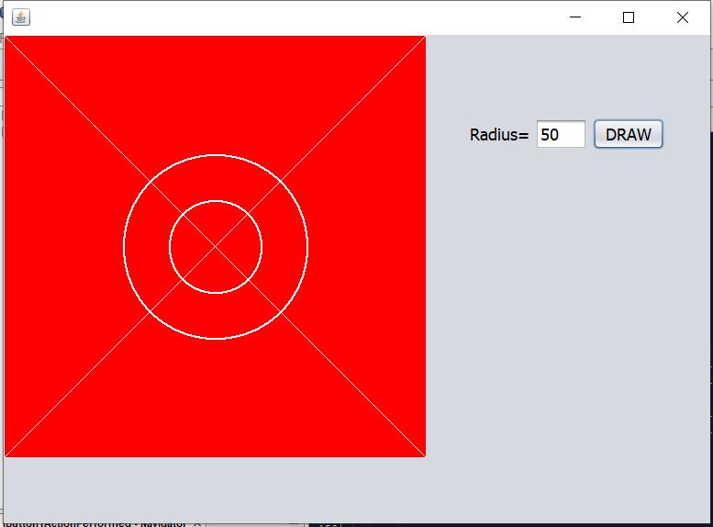
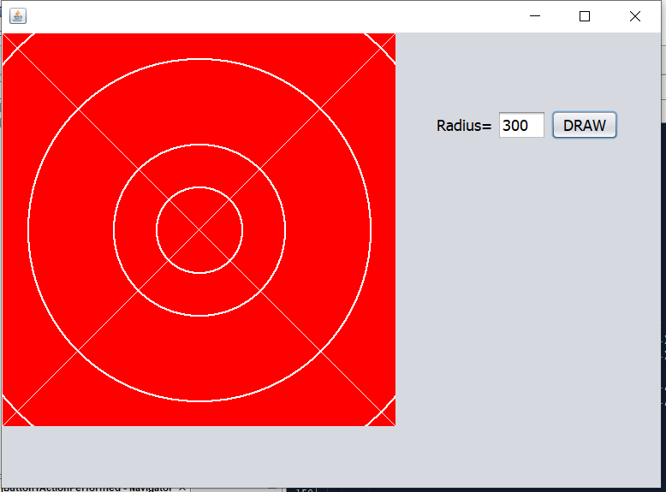

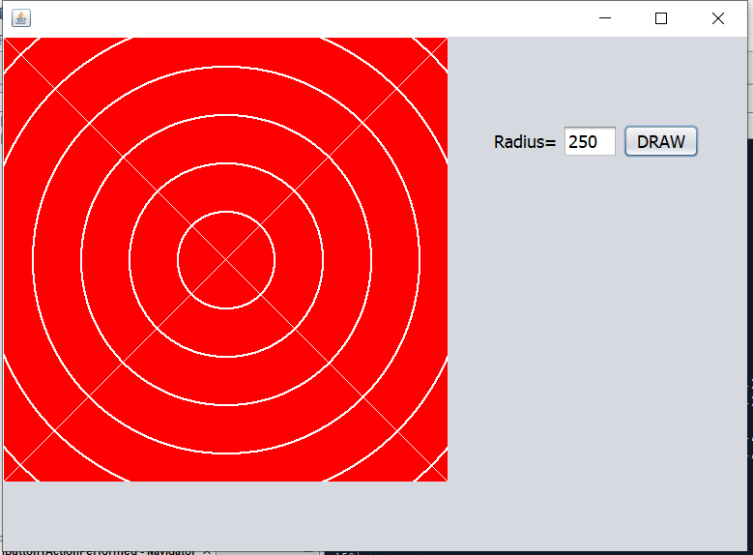

ADDITIONAL TASK

Task of Work
- Make it possible to define the position and size of the circle by using the mouse (cursor position), by defining 2 points: the center of the circle and a tangent point (point of tangency).
Upload all program files to Ortus in an archive (in *.arj, *.zip or *.7z formats)
- Programming Code
package pack2;
import java.awt.Color;
import java.awt.Graphics;

public class NewJFrame extends javax.swing.JFrame {
int flag=0;
double x1,y1,x2,y2,z;
}
private void jButton1ActionPerformed(java.awt.event.ActionEvent evt) {
Graphics g = jPanel1.getGraphics();
g.setColor(Color.WHITE);
g.drawLine(0,0,jPanel1.getWidth(),jPanel1.getHeight());
g.drawLine(0,jPanel1.getHeight(),jPanel1.getWidth() , 0);
int w = jPanel1.getWidth();
int h = jPanel1.getHeight();
g.drawLine(0, 0, w, h);
g.drawLine(0, h, w, 0);

// int xC = w/2;
// int yC = h/2;
// g.drawLine(((int)x1), 0, ((int)x1), h);
//g.drawLine(0, ((int)y1), w, ((int)y1));

int R =Integer.parseInt(jTextField1.getText());
int pn = 1-R;
int xn = 0;
int yn = R;
while (xn<=yn){
if (pn<0){
xn++;
pn = pn + 2*xn;

} else {
xn++;
yn--;
pn = pn +2*xn-2*yn;

}

g.drawRect((xn +((int) x1) ) , (((int) y1) + yn), 1, 1);
g.drawRect((xn +((int) x1)) , (((int) y1) - yn), 1, 1);
g.drawRect((((int) x1) - xn) , (yn +((int) y1)), 1, 1);
g.drawRect((((int) x1) - xn) , (((int) y1) - yn), 1, 1);
g.drawRect((yn + ((int) x1)) , (xn +((int) y1)), 1, 1);
g.drawRect((((int) x1) - yn) , (xn + ((int) y1)), 1, 1);
g.drawRect((yn + ((int) x1)) , (((int) y1) - xn), 1, 1);
g.drawRect((((int) x1) - yn) , (((int) y1) -xn), 1, 1);

}

}

private void jPanel1MouseClicked(java.awt.event.MouseEvent evt) {

if (flag==0){
x1= evt.getX();
y1 = evt.getY();
flag=1;
} else if(flag==1){
x2 = evt.getX();
y2 = evt.getY();
flag=0;}
z =Math.sqrt((x2-x1)*(x2-x1)+(y2-y1)*(y2-y1));

jTextField1.setText(Integer.toString((int) z));
}

Screen Shots
